caImage Upgrade

Software Design Description

Release 1.5

Document Change Record
Version Number | Date | Description
1.0 | 11/5/2009 | Initial document
1.1 | 11/9/2009
1.2 | 12/4/2009

TABLE OF CONTENTS
1. Introduction 1
1.1 PROJECT BACKGROUND 1
1.2 identification 1
1.3 Requirements 1
1.4 System Overview 2
1.4.1 System Development 2
1.4.2 Operations and Maintenance 2
1.4.3 Key Stakeholders 2
1.5 Document Overview 2
1.6 Reference documents 3
2. System Architecture 4
2.1 SYSTEM Architecture OVERVIEW 4
2.1.1 Client Tier 4
2.1.2 Presentation Tier 4
2.1.3 Business Tier 4
2.1.4 Persistence Tier 4
2.1.5 Enterprise Information System (EIS) Tier 4
2.2 SYSTEM Deployment 4
3. Components 6
3.1 Application Software 6
3.1.1 Image Submission 6
3.1.2 Image Retrieval 6
3.1.3 Software Package 6
3.2 Data Model 6
3.3 File Repostory 7
3.4 Image Viewer 7
3.4.1 Adore-Djatoka Image Viewer Installation/Integration 7
3.4.2 Adore-Djatoka Image Server Installation 8
3.4.3 Image Conversion 8
3.4.4 Image Hosting 8
3.5 Security 8
Appendix A – acronym List 10

Introduction
The purpose of this document is to describe the design for the caImage upgrade - Release 1.5. The caImage upgrade.

PROJECT BACKGROUND
caImage is a web-based portal for accessing histology images submitted by fellow researchers. Researchers can submit images via the web-based portal and query for images and image annotations by species, organ, tissue, and diagnosis.

caImage is also leveraged by the NCI’s cancer Model Organisms Database (caMOD) and the NCI’s emice web site supporting the Mouse Models of Human Cancer Consortium (MMHCC).

identification
The system identification information to which this document applies is as follows:
- Title: caImage
- Abbreviation: caImage
- Version: 1.5
- Release Number: 1.5

release scope
The scope of caImage release 1.5 is as follows:
- Migrate the caImage application from the current, outdated technology stack to the latest NCI CBIIT technology stack (see 1.4 for details).
- Replace the unsupported, proprietary LizardTech image viewing technology with up-to-date, open source image viewing technology (see 1.4 for details).
- Disable the current image submission functionality and replace it with an image submission solution for system administrators.

Requirements
The following is a list of high-level functional and technical requirements for the caImage upgrade effort.
Req. # | Requirement
1.0 | The system shall utilized the latest NCI CBIIT technology stack
1.1 | The system shall be ported to the JBoss 5.* application server and the Java 1.5 runtime environment.
1.1.1 | The system shall be ported to Oracle 10g database software.
1.1.2 | The system shall be ported to a Linux operating system.
2.0 | The system shall provide support an open source image viewer
2.1 | The system shall utilize the Adore-Djatoka image server software as a replacement for the LizardTech image server software.
2.2 | The system shall utilize the javascript-based Adore-Djatoka image viewing technology as a replacement for the LizardTech image viewing technology.

Table 1-1: Requirements Matrix

System Overview
The primary goals of the caImage Release x.x effort are to:
- Upgrade the caImage application to the latest NCI CBIIT technology stack
- Transition of the proprietary LizardTech image viewing software to an open source image viewer (Adore-Djatoka)

System Development
The caImage effort is being designed and developed following the Rational Unified Process (RUP) in an iterative fashion. As such, it is intended that this document will be updated frequently during the elaboration phase.

Operations and Maintenance
The reference implementation of caImage is being deployed and maintained at the NCI CBIIT as a central repository of histology images for use by the community.

Key Stakeholders
Key stakeholders associated with the effort are defined as follows:

- Research community
- Image contributors including UC Davis and other institutions
- MMHCC

Document Overview
This document provides an overview of the caImage system design as it pertains to the upgrade effort. It is intended to describe and capture the caImage design decisions and is written as a reference for both the NCI customer and the NCI contractors/developers involved with the evolution of caImage. This is a living document and will be updated to reflect the evolution of development, as well as future enhancements and upgrades.
The main sections of this document are listed and described below.
- Section 1. Introduction: provides a purpose statement, project background, requirements matrix, system overview, and document overview.

- Section 2. System Architecture: describes an overview architecture design of the caImage and the various environments that will be used throughout the development lifecycle.
- Section 3. Components: describes design details of the system components: technology stack, image viewer, data model, package structure, user interface, business services, file repository structure, and user authentication and authorization.

Reference documents
Document Name | Location
caImage Upgrade Design Document | SVN Server: ; module: caimage; Directory: docs/Scope
caImage Application | http://cancerimages.nci.nih.gov/caIMAGE/index.jsp

Table 1-2: Reference Documents

System Architecture

SYSTEM Architecture OVERVIEW
The caImage system is designed as 2-tier system that provides high-resolution image searching, viewing, and submission capabilities via a web application that communicates with an image server. Image metadata is stored in the caImage database and used to construct requests for the image server.

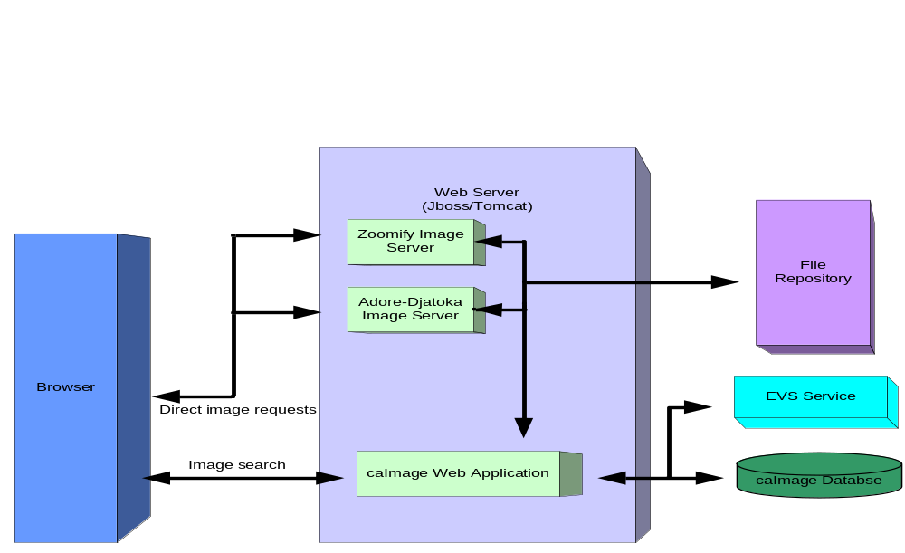
Figure 2-1: System Architecture

Client Tier
The caImage client tier consists of web browsers (e.g. Internet Explorer, FireFox, etc.) served HTML, Javascript, Cascading Style Sheets (CSS) and images. caIMAGE will support the browser and user interface standards put forward by the NCICB User Interface working group and will incorporate NCICB’s 508 compliance guidelines. The application client layer will utilize HTML and style sheets.

The Client Tier also includes image viewer technology, served as HTML, Javascript, and CSS, that allows users to zoom and pan the images served by the image server.

Presentation Tier
The caImage presentation tier is implemented using the J2EE 1.4 implementation of Java Server Pages (JSPs), JSP custom tags and servlet technologies.

Business Tier
Since caImage is a 2-tier application, the business tier is tightly coupled with the presentation tier; however, a Servlet interface is provide to facilitate the integration between caImage, caMOD, and Emice. An interface to the NCI Enterprise Vocabulary Services (EVS) is also provided to facilitate image search/submission using common terminology for organ/tissue and diagnosis.

Persistence Tier
The persistence tier is responsible for executing queries to the underlying data sources and fetching query results. The caImage persistence tier is implemented using straight JDBC calls to the underlying Oracle database. The database will be updated from Oracle 9i to Oracle 10g.

Enterprise Information System (EIS) Tier
The EIS tier is the backend tier that is responsible for providing and storing images. The caImage EIS tier consists of a caImage repository on the network file system.

SYSTEM Deployment
caImage is designed to be deployed in any Servlet container that conforms to Java Servlet specification 2.4 and JSP specification of 2.0. For both NCICBIIT and NCL deployments, JBoss Java 2 Enterprise Edition (J2EE) application server integrated with Apache web server is used to host the application.
At the NCICBIIT, the caImage system is deployed in a four-tier hardware environment comprising development, QA, staging and production.

Components

Application Software

Image Submission
User-submitted images are currently transferred to the LizardTech server via FTP and categorized as 'External'. In release 1.5, image submission via the caImage UI will be disabled, as user submissions are rare and are no longer necessary. A script will be implemented to allow system administrators to submit images directly via the file repository.

Image Retrieval
Currently, image requests to the LizardTech image server are constructed by creating URLs that contain
- the image category
- the image name
- size/resolution/extraction-area data for the image to be returned
Links to images are constructed dynamically in JSP pages using the results of database queries. The location of the image to be served is resolved by the LizardTech server by mapping the image category to a file directory and then locating the image by name.
In release 1.5, image retrieval functionality will be updated as follows:
- The names of image files in the caimage database will be updated to reflect the names of the converted image files. This will be scripted based on the results of the image conversion script. The only change should be changing the file extension from .sid to the converted file format.
- Image categories will be mapped to the file directory structure of the new image server. The intent is to retain the LizardTech directory structure on the new server such that the mapping can be accomplished by investigating the mapping currently in place on the LizardTech server. The new mappings can be placed in a configuration file in the caimage application.
- caImage JSP files will be updated such that image requests are constructed for the Adore-Djatoka server rather than the LizardTech server. The LizardTech image server URL will be replaced with the new Adore-Djatoka URL; the image category and name will be converted to an image location by using the category mapping configuration file; size/resolution/extraction-area data will be converted to the format required by Adore-Djatoka.

Software Package
The caImage root package is gov.nih.nci.caimage. The source-code package structure is as shown in Figure 3-16.

- gov.nih.nci.caimage – Contains database and file conversion utility classes.
- gov.nih.nci.caimage.Servlet – Contains a URL dispatch servlet.
- gov.nih.nci.caimage.util – Contains presentation layer utility classes.

Figure 3-16: caImage Source Package Structure

caImage application software includes the UI implemented using Java Server Pages with embedded Java code.

Data Model
At the core of the caIMAGE application are the business or domain objects and the relationships they share. Cancer models can be of a variety of types and, caIMAGE will be designed to be extendable, allowing for the capturing of Animal Model cancer data, anti-cancer Yeast and Invivo screening data, as well as other types of cancer models in the future. Each model may share several common business objects that in the context of a specific model type but, may have different associations. For this reason, we will capture the known cancer model designs in separate UML diagrams with a diagram to render their high-level associations. These domain/business objects will be implemented as Plain Old Java Objects (POJOs). The identified domain objects and their relationships are captured in the following sections. In caImage, users can upload image files, and the uploaded files are stored on a network file system accessible to the server that hosts the application server serving the caImage application. A pre-defined directory structure and file naming conventions are employed to prevent uploaded files with same names overwriting each other.

3.3 File Repository

Current implementation: when a file is uploaded, a timestamp in the format of yyyyMMdd_HH-mm-ss-SSS is added to the beginning of the filename as $NEW_FILE_NAME = $TIMESTAMP_$ORGINAL_FILENAME, e.g. 20061211_10-30-46-773_NCL200612A_fig 20.jpg. The new file name is saved to the appropriate directory on the file repository and file URI ($DIRECTORY/$NEW_FILE_NAME) is saved to the database. The following table describes the pre-defined directory structure for the different file types:

File Type | Directory Structure
Histology Image | $ROOT/histopathology

In release 1.5, image submission via the caImage application will be disabled as it is no longer used. A script will be implemented that will enable system administrators to copy images directly to the file repository and enter image metadata to be persisted in the caImage database.

Image Viewer

Adore-Djatoka Image Viewer Installation/Integration
Adore-Djatoka provides a free, open-source, javascript-based image viewer implementation based on the IIPMooViewer project. The image viewer is server-side technology that requires the integration of javascript and css files into the caimage web application. Once the files bundled with the viewer distribution are installed in caImage, web pages can be easily constructed to view files served by the Adore-Djatoka image server.
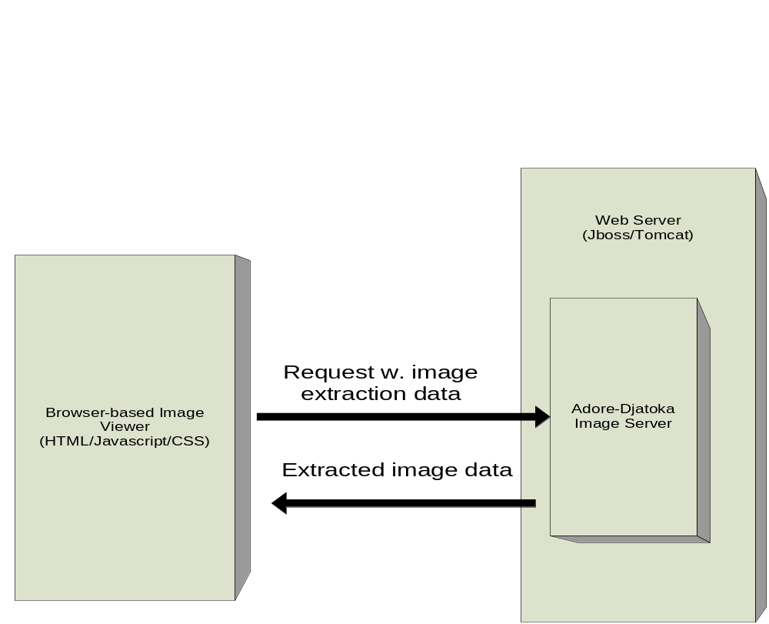
Figure 3-1: Image Viewer

Adore-Djatoka Image Server Installation
Installation of the Adore-Djatoka image server requires
- Installation of platform-specific image extraction and compression binaries, which are bundled with the Adore-Djatoka distribution
- Deployment of the Adore-Djatoka web application to a Java application server via the WAR file bundled with the distribution. The installation requires setting an environment variable on the server pointing to the installation directory of the extraction/compression binaries, and the addition of some system properties to the configuration file of the Java application server (for JBoss 5.*, the run.bat.conf file or the run.conf file, depending on the operating system environment.)

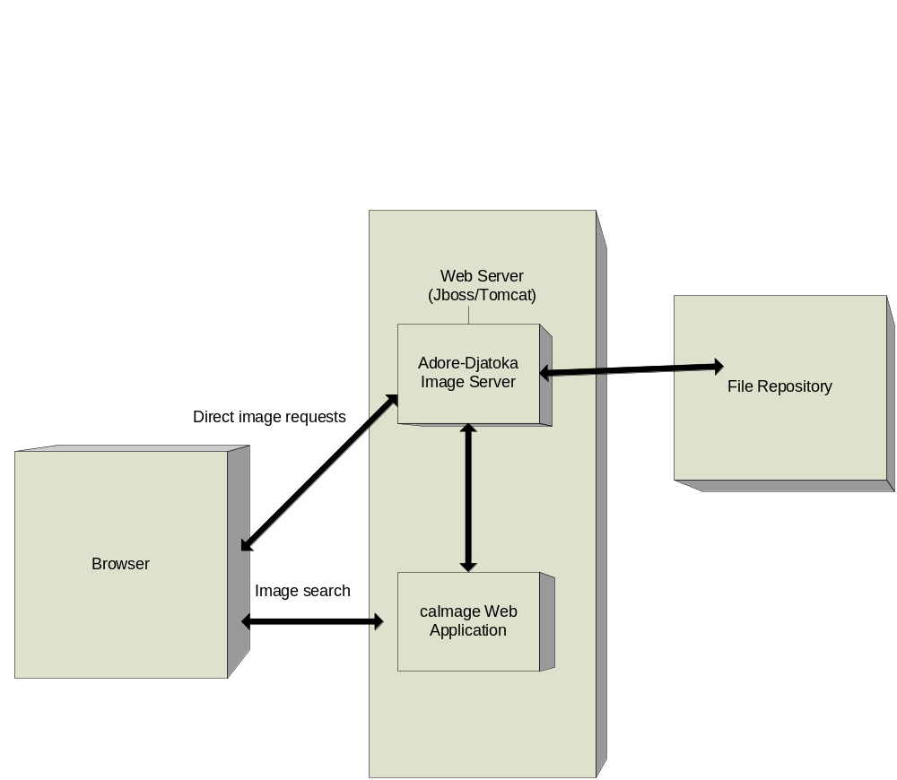
Figure 3-2: Image Server

Image Conversion
Currently, the caImage file repository contains images in the proprietary SID format, and the images are viewed using the LizardTech image server technology. In release 1.5, the images will be converted to an open format so they can be handled by the Adore-Djatoka image server. LizardTech provides a free command-line tool that can be used to convert SID images to TIFF or JPEG images. TIFF is the preferred image format as it provides a lossless conversion; however, the TIFF file format has a 4GB file size limit, and some of the caImage SID files are too large to be converted to TIFF files that adhere to this limit. An interim solution for the conversion of these large files is to convert the files to the JPEG format while retaining the original SID images to allow for an alternate solution should one arise.
Image conversion using the command line tool can be scripted such that:
- The original SID images are retained
- The directory structure of the original file location is mirrored in the directory structure of the converted images
- The conversion of large numbers of images can be initiated and completed without further manual intervention.
- Images that cannot be converted to TIFF will be converted to JPEG.

Image Hosting
Images served by the Adore-Djatoka image server can be hosted independently from the Adore-Djatoka web application. Image URLs are provided to the Adore-Djatoka image server which then retrieves and caches the images and provides zoom/pan capabilities.
Zoomify images are currently hosted on the server on which the Zoomify server application resides, and this will not change in release 1.5.

Security
User authentication and authorization in caImage is implemented using database storage of user names and passwords.

Appendix A – acronym List
Acronym | Description
caBIG | Cancer Biomedical Informatics Grid
caMOD | Cancer Model Organisms Database
CSM | Common Security Module
CSS | Cascading Style Sheet
EIS | Enterprise Information System
EVS | Enterprise Vocabulary Services
J2EE | Java 2 Enterprise Edition
JSP | Java Server Page
NCI CBIIT | National Cancer Institute Center for Biomedical Informatics and Information Technology
UI | User Interface

